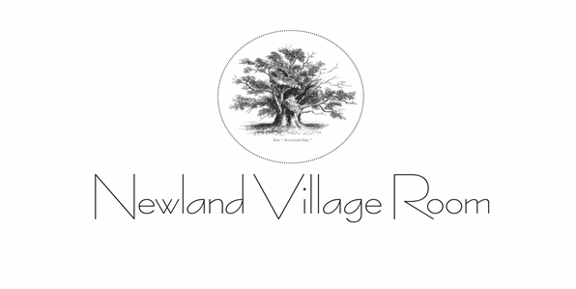.

MINUTES OF AGM 3rd August 2022 @ 7.00pm
Relating to the year 1 January 2021 to 31 December 2021
At Newland Village Room and On Zoom

- APOLOGIES – Gill Hartle, Ian Hayward, Lucy Davies, Will and Kate John,

- MINUTES OF THE AGM OF 11 AUGUST 2021 – there were no questions on the content. Proposed by Paul McMahon, and seconded by Jennie Hayward. Unanimously accepted.

- CHAIR’S REPORT – as per Appendix A below. Karen Davies also added that she thanked the whole committee for individually and in groups taking on projects which made for a well-oiled machine.

- TREASURER’S REPORT – as per the attached Appendix B. Jules Pritchard proposed a vote of thanks to Steve Brettle for his sterling work as treasurer, Karen Davies seconded.

- 100 CLUB REPORT – the Chair referred to the spreadsheet provided for details.

- ACCOUNTS FOR 2021 – These were more detailed than previously and required the accountants to undertake more work due to the Covid grants increasing the gross income to more than £25,000 in this particular year. Paul McMahon proposed the accounts and Jules Pritchard seconded. All in favour.

- ELECTION OF COMMITTEE MEMBERS – the current committee consisted of Jane Bentley, Steve Brettle, Karen Davies, Jules Pritchard, Paul McMahon, Emma Wrafter, Sara Stephens. All except Paul McMahon are standing for re-election. It was proposed to elect the committee en bloc. Proposed by Paul McMahon and seconded by Jennie Hayward. Elected unanimously. Russ Horner is to be co-opted to the Committee as non-trustee members.

Paul McMahon was not standing for re-election after 6 years of being on the Committee. He said that he had very much enjoyed being part of the team but it was time for him to go. The chair, on behalf of herself and the remaining committee members thanked Paul for his support and hard work throughout his tenure and said that he would be sorely missed.

- ELECTION OF OFFICERS – the following were standing unopposed: Karen Davies as Chair, Steve Brettle as Treasurer, Jules Pritchard as secretary, Jane Bentley as publicity officer.
Proposed by Jennie Hayward and John Hartle seconded. Unanimously accepted.

- QUESTIONS OR COMMENTS – Jennie Hayward asked if there would be a replica of the grants received in 2021 in 2022. The Chair confirmed that this was a one off due to the pandemic. Paul McMahon also mentioned that the Parish Council grant was not likely to be forthcoming for three years due to the levels of monies paid out to the three village halls.

- ANY OTHER BUSINESS – there was none.

- Meeting concluded at 7.30pm

APPENDIX A – ATTENDEES
11th August 2021– ATTENDANCE LIST

Jane Bentley (Zoom)
Karen Davies
Steve Brettle
Emma Wrafter (Zoom)
Jules Pritchard
Jennie Hayward
John Hartle
Sarah Stephens
Russ Horner
Paul McMahon

APPENDIX B – CHAIR’S REPORT

See document in Documents section on www.newlandvillageroom.co.uk

APPENDIX C – TREASURER’S REPORT

See document in Documents section on www.newlandvillageroom.co.uk

