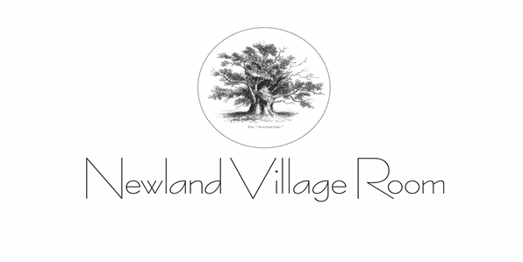.
Charity No: 1113011

HIRE FORM

Please complete all of the questions below

1 Is the hire for you or for an organisation? If for an organisation, full name and address of that organisation, and your position within that organisation

2 Please may we have your full name, address and telephone number?

3 Please confirm your email

4 For what purpose will you be using the Room and is it for a private or public function?

5 Is alcohol being provided?

6 is it being sold?

7 Will music be played?

I confirm that I have read the Standard Conditions of Hire to be found in the Documents Section of www.newlandvillageroom.co.uk and agree that these together with this form constitute the terms of the contract of hire. Also, I agree to leave Newland Village Room in a clean and tidy condition and to dispose of all rubbish in the appropriate bins outside the Village Room, including food waste.

Payments should be made to the following account. Please note that this account is a new one as at 1 November 2023

Newland Village Room
Sort Code: 30-66-77
Account No: 67320960
Ref: Hire [date of hire]

